Name: Date: ore words

The sound (or) is usually represented by the letters ore when it comes at the end of words, like in the words below.

Remember: Say the word aloud, then say each letter aloud as you write it e.g. 'more, m ... o ... r ... e'

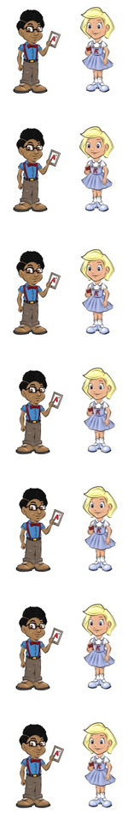
Would you like more?

The score in the game was 1-0.

A store is another name for a shop.

Waves from the sea crash on to the shore.

Neil tore Gail's dress.

Some people snore when they sleep.

What do you do before (be/fore) you go to bed?

The words below are naughty red words that belong to Nina and Neil because they use the letters oor to represent the sound (or) at the end of them.

Please shut the door on your way out.

If someone is poor, they do not have much money.

The floor is what you stand on when you are inside.

Now test yourself without looking at the words and check for yourself if you got them all right. Practice writing any words that you made mistakes on again.

© www.SaveTeachersSundays.com 2013
Name: Date: ore words

The sound (or) is usually represented by the letters ore when it comes at the end of words, like in the words below.

Remember: Say the word aloud, then say each letter aloud as you write it e.g. 'more, m ... o ... r ... e'

Try to spell each word without looking at it.

Would you like ?

The in the game was 1-0.

A is another name for a shop.

Waves from the sea crash on to the .

Neil Gail's dress.

Some people when they sleep.

What do you do you go to bed?

Please shut the on your way out.

If someone is , they do not have much money.

The is what you stand on when you are inside.

Now check for yourself if you got them all right. Practice writing any words that you made mistakes on again.

© www.SaveTeachersSundays.com 2013

